This document has prioritised sharing useful resources that you can use to support distance learning, emotionally reassure the pupils and help them to thrive during these challenging times.
Here are some initial articles and resources I wanted to share with you:
For parents and for educators
- Distance Learning Solutions to Mitigate COVID-19 - UNESCO
- How to give your kids stability when Coronavirus closes school - Quartz
- How to talk to your children about Coronavirus - UNICEF
- What if Coronavirus means your kids are stuck at home? The Cut
- How working parents can prepare for coronavirus closures. Harvard Business Review
- Navigating Uncertain Times: How schools can cope with Coronavirus - Edsurge
- Preparing for distance learning due to school closures - Newsela
- Keep calm and trust in edtech: tools for teachers - Education Technology
- Teach students to wash hands properly with this dance challenge! - BBC Bitesize
I hope that you find these resources helpful and I invite you to share them with your wider community also.

Online learning provision
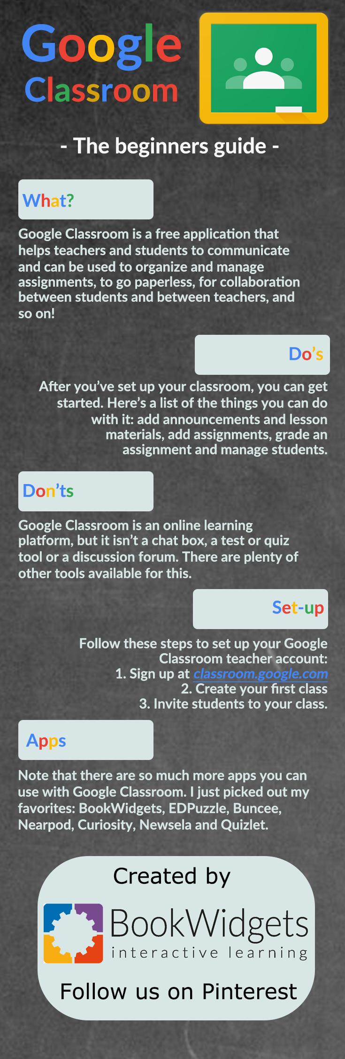
Whilst Southwark School Improvement team is always optimistic about life in general, we are asking school to begin to make contingency plans in the event of government instructions to close schools. It is important to think about these plans now as you may need to test remote working, set up google classroom and provide additional CPD for staff to work remotely.
Online learning and Virtual Classrooms
How are you as a school set up for remote and online learning?
Google Classroom
Google Classroom enables teachers to create an online classroom area in which they can manage all the documents that their students need. Documents are stored on Google Drive and can be edited in Drive’s apps, such as Google Docs, Sheets, and so on. But what separates Google Classroom from the regular Google Drive experience is the teacher/student interface, which Google designed for the way teachers and students think and work.
How to get started with Google Classroom
Like other Google applications, you need a Google account to use it. But not just any Google account will do for Classroom; you need a Google Apps for Education account. This is different than your standard Google account. Follow the steps below to set one up
- Open a Web browser and go to classroom.google.com You have to sign in with a Google account.
- If you’re using a regular Google account, you’ll see a message that says “Sorry! Classroom is only available for Google Apps for Education Users at this time.” Click the Get Started with Apps button.
- On the Google Apps for Education page, you can read all about the service, or just click the Get Apps Today button in the top right.
- Fill out the form with your institutional information and click Next.
- Most likely, your school has a Web site and you’ll want to use that. Click the Use a Domain Name < your school website> I Have Already Purchased option and type in the domain (see Figure 1).
- Click Next.
- Type in the username and password that you want to use
https://edu.google.com/intl/en-GB/products/classroom/?modal_active=none
iTunes U
iTunes U provides everything an instructor needs to bring the classroom together on iPad — build lessons with apps and your own materials, collect and grade assignments, start class discussions, or talk to students to answer questions and provide feedback.
iTunes U also allows anyone with an iPhone, iPad or iPod touch to learn from a large collection of free education content in public courses from leading schools, universities, museums and cultural institutions.
For Instructors:
• Plan lessons, grade assignments and stay connected — direct from your iPad
• Add your own teaching materials — including worksheets, links, photos and videos from a variety of document providers
• Engage every learner using apps, books, videos, podcasts and more
• Add instructions or comments to PDFs and photos with built-in annotation tools
• See when students have viewed or completed assignments and remind them of due assignments
• Use the single-student view for individual attention at parents’ evenings
• Answer questions and provide video feedback or start class debates using group discussions
• Institutions using Apple School Manager and Managed Apple IDs can import registers to streamline course creation
• Teachers affiliated with qualified institutions can publish courses to the iTunes U catalogue for anyone to view for free on iOS devices
For Students:
• View assignments and updates in one place, and tick off assignments you complete
• Submit your work in private courses from other apps, or as annotated PDFs and photos
• Open audio or video files directly in other apps
• Ask instructors questions or get feedback in 1:1 messages
• Start or join group discussions with your class
• View your grades and instructor feedback on all past assignments

Browse a rich catalogue of free education content:
• Choose from a variety of free lectures, videos, books and more on a range of subjects from leading educational and cultural institutions around the world, including Stanford, MIT, Yale, La Trobe University, University of Tokyo, Smithsonian Libraries, US National Theatre and more.
• Share your favourite courses with friends using Twitter, Facebook, Mail and Messages
Privacy:
iTunes U stores information about your activity in the app, such as materials you upload. To improve the app, iTunes U collects non-personally identifiable information related to app usage and browsing history of public content. Data is retained until an action is taken to remove it by any of the means provided.
Requirements:
• Participating in courses requires iPhone, iPad or iPod touch
• Built-in PDF or photo annotation requires iPad (4th generation or later) or iPad mini 2 or later
• Publishing public courses to iTunes U requires teachers to be affiliated with a qualified institution

Make your approach inclusive:
- If you are giving guidance make sure that you give a range of ideas for additional learning.

