**Tuke School Cleaning operative**

15 hours per week. Hay Grade 1, Spine point 2 - £27,306 Pro rata (£9,793)

Term Time only Start Date – ASAP

**Thinking about working in a School?**

**Come and work here….**

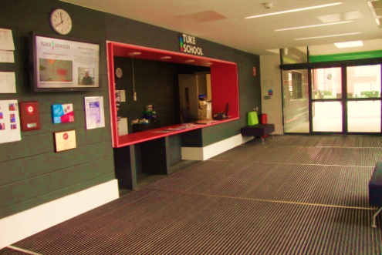Tuke is a Secondary Special School, meeting the needs of young people with severe, profound and complex learning needs.

Tuke is a purpose built special school which provides specialist facilities for all of our students.

At the heart of our ethos and building design is our mission statement and school values:

**“Learning everywhere, inspiring everyone”**

**Creativity, Opportunity, Achievement, Positivity**

We are looking to appoint a highly motivated, flexible and enthusiastic school cleaner to work within a small but dedicated cleaning team.

The role will be responsible for cleaning designated areas within school premises to ensure that they are kept in a clean and hygienic condition. Duties will include: cleaning, washing, sweeping, vacuum cleaning, emptying of litter and clinical waste bins, polishing and dusting of the designated areas (which may include toilets and shower areas) and fixtures and fittings, using where appropriate powered equipment.

The hours are Monday to Friday 4.00pm to 7:00pm during school term time

We can offer you :

* Regular working hours
* Friendly, motivated staff to work with
* Training and support for your role
* Personal development opportunities
* A vibrant and stimulating working environment

You will need to have:

* Positive, calm and flexible approach to a busy work environment
* Good physical health
* A working knowledge of health and safety requirements
* An ability to understand and follow written and verbal instructions
* A flexible approach and be able to work as an effective team member

**Tuke School is committed to safeguarding and promoting welfare of children. The nature of this post will require the successful applicant to be enhanced DBS checked**

Visit our website – [www.tukeschool.co.uk](http://www.tukeschool.co.uk)

To visit or request an application pack, visit our school website or contact Emma, our Office Manager on:**020 7525 8002**

Closing date for receipt of applications is 7th October 2025

Interview will take place on 13th Oct 2025.

We cannot accept CV's.

Short listed applicants will be notified with an interview time.

**If you are shortlisted, we will request references prior to the interview.**