
Available class teacher role for September 2026 or before
Salary MPS (including inner London allowance) +SEN 1

Our school provides specialist facilities for students with Severe, Profound and Complex Learning difficulties. At the heart of our curriculum and design is our mission statement:
“Learning everywhere, inspiring everyone”
and our school values
Creativity Opportunity Achievement Positivity

Tuke school was judged ‘outstanding’ for the past 4 OFSTED inspections.
The latest OFSTED report stated:
‘ Tuke School is a very special place. Pupils reach personalised and ambitious goals because of the school’s support. Every part of school life is designed around the school’s high expectations to meet the needs of individual pupils’

‘ A strength of this school is the close working relationship between teachers, support staff and pupils. Staff know their pupils extremely well and provide consistent and individualised approaches to support exemplary behaviour.’

We want to appoint a committed and creative class teacher who is vibrant and passionate about motivating and engaging young people to learn, explore and experience.
We actively encourage career development and respect initiative and ambition.
We welcome applications from newly qualified and experienced teachers.

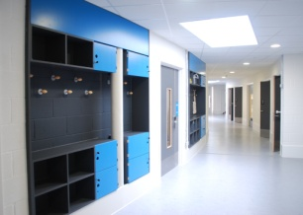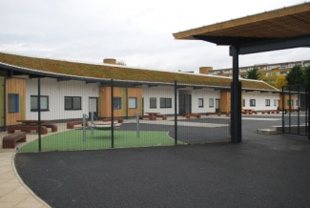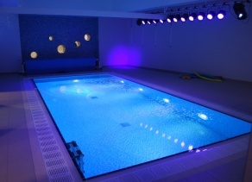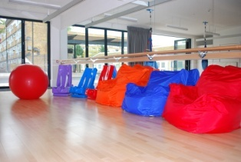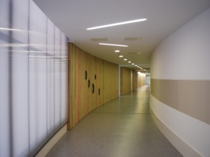

Please download an application pack from the TES and the School website www.tukeschool.co.uk
Or contact the school office: 020 7525 8002 Tuke School, Daniel Gardens, SE15 6ER.
Interested candidates are strongly recommended to arrange a visit to our school.

Closing date for application 24th June 2026
Interviews to be held from 26th June 2026 -

Shortlisted applicants will be contacted with an interview time and date.

Southwark LA and school governing body are committed to safeguarding and promoting the welfare and well-being of children and young people. This post is subject to enhanced disclosure procedures.

